OFFICIAL COORDINATION REQUEST FOR
NON-ROUTINE OPERATIONS AND MAINTENANCE

COORDINATION TITLE- 20BON81 Spillway Hydro-survey
COORDINATION DATE- 8/12/2020
PROJECT- BON
RESPONSE DATE- 26 August 2020

Description of the problem

With this season’s spill exceeding the levels known to cause rock migration into the stilling basin, there is a need for a hydro survey to check for location and extent of rock accumulation. We will need spill bays 1 and 18 closed, one at a time, for up 8 hours.

Type of outage required

Impact on facility operation: (FPP deviations) Closure of Spill bay 18 which is attraction flow for B-branch fishway entrance, and Spill bay 1 which is attraction flow for the Cascades Island entrance.

Impact on unit priority: none

Impact on forebay/tailwater operation: none

Impact on spill: Spill will be finished for the season, but attraction flow will be reduced by 0.5 kcfs for the duration of this work.

Dates of impacts/repairs: 1 September 2020

Length of time for repairs: 1 day

Analysis of potential impacts to fish

 | 10-year average for work period | total run 10-year average | % of run affected
Chinook | 11,494 | 521,629* | 0.0220
Coho | 1,167 | 93,314 | 0.0125
Chum | 0 | 126 | 0
Steelhead | 2,336 | 233,821 | 0.0099
Lamprey | 109 | 125,757** | 0.0008
*Fall run Chinook
**8 year average
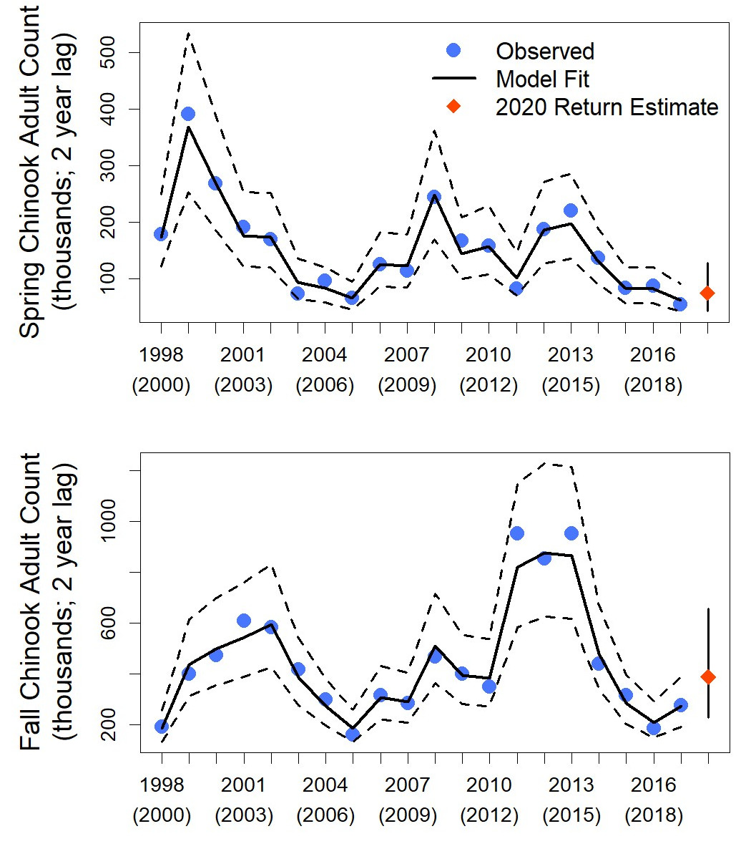

Chinook | See above
Coho | Forecast below average
Chum | No forecast
Steelhead | Forecast below average
Lamprey | Below average
*From NOAA
With no attraction spill, passage through spillway routes may be reduced. Fish that do approach the B-Branch and Cascade Island ladders will encounter fully functional ladders but may have to search longer for fishway entrances with no attraction water. Those fish may be exposed to increased sea lion predation. Stellar Sea Lion abundance for this time is ~16 animals, no California Sea Lions.

Summary statement - expected impacts on:

Downstream migrants Very minimal. There are no major annual downstream migration events on this date. Spill will have already ended and very few fish would pass the spillway through attraction flow releases.

Upstream migrants (including Bull Trout) With attraction flow from only one side of the spillway, fish in the area may be drawn to the opposite side of the spillway or delay, though both ladders will be fully operational. The delay could an increase in sea lion predation.

Lamprey None.

Comments from agencies

Final coordination results

After Action update (After action statement stating what the effect of the action was on listed species. This statement could simply state that the MOC analysis was correct and the action went as expected, or it could explain how the actual action changed the expected effect (e.g., you didn’t need to close that AWS valve after all, so there was no impact of the action). List any actual mortality noted as a result of the action)

Please email or call with questions or concerns.
Thank you,
Erin

Erin Kovalchuk
NWP Operations Division Fishery Section
Columbia River Coordination Biologist
Erin.H.Kovalchuk@usace.army.mil

And

Andrew Derugin
Fish Biologist & Research Coordinator
Bonneville Lock & Dam
U.S. Army Corps of Engineers
o: 541.374.3879
m: 503.278.2376

